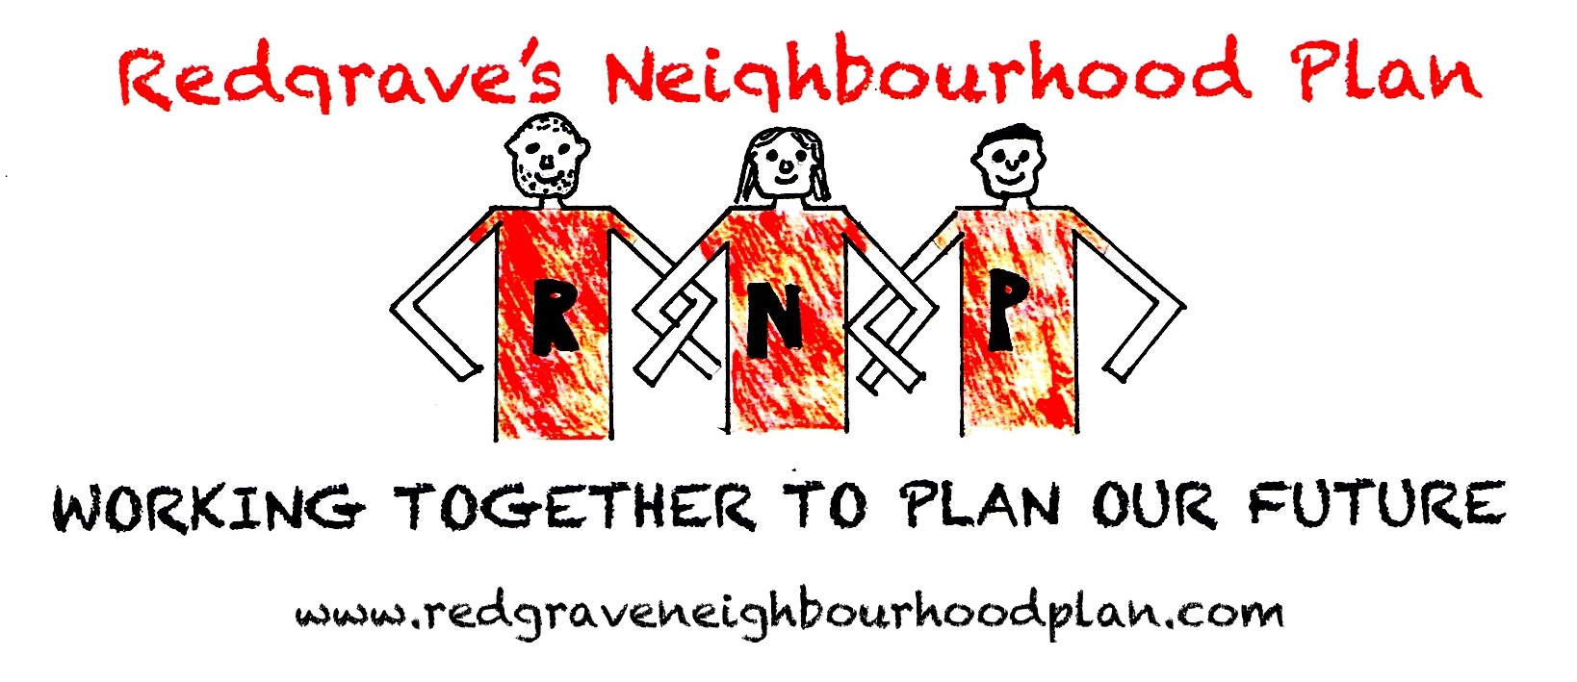
Site Submission Form
Call for sites, 1st October 2019 to 12th November 2019

FOR OFFICIAL USE ONLY

Response Number:

Date Received:

This form is to be filled out by any interested parties who want to promote a site for a specific use or development to be allocated in the Redgrave Neighbourhood Development Plan.

The Babergh Mid Suffolk Joint Local Plan BMSJLP) is being produced by Babergh District Council and Mid Suffolk District Council working together. They undertook a ‘Call for Sites’ in 2018. This covered sites across the two Districts.

The Redgrave Neighbourhood Plan Steering Group is undertaking a further ‘Call for Sites’ just for the Redgrave Parish Area to see if there are any sites that might be suitable for future development in the Parish that were not put forward as part of the BMSJLP consultation in and to check that those that were put forward during that consultation are still available.
Only one form should be submitted for each individual site i.e. it is not necessary for a separate form to be completed for each landowner on a single site in multiple ownerships. However, a separate form must be completed for each individual site submitted.

Forms can be submitted by email to redgraveneighbourhoodplan@gmail.com
Forms must be received by midnight on 12th November 2019

Or, if it is not possible submit the form electronically, hard copy forms can also be sent to:
Redgrave Parish Clerk
Wayside Cottage
Cherry Tree Lane
Botesdale,
Diss, IP22 1DL

The site submissions received as part of Redgrave Neighbourhood Development Plan Call for Sites Consultation will be published and made available for public viewing. By submitting this form you are consenting to the details about you and your individual site(s) being stored by Redgrave Parish Council and shared with Mid Suffolk and Babergh District Councils, as partners in the BMSJLP and that the details of the site will be published for consultation purposes. Under the (GDPR) General Data Protection Regulation Redgrave Parish Council will be the data controller.

1a. Contact Details
Title
First name
Last name
Job Title (where relevant)
Organisation (where relevant)
Address
Postcode
Telephone number
Email address

1b. I am…
Owner of the site | Parish/Town Council
Developer | Community group
Land agent | Local resident
Planning consultant | Registered Social Landlord
Other (please specify):

1c. Client/landowner details (if different from question 1a)
Title
First name
Last name
Job title (where relevant)
Organisation (where relevant)
Address
Postcode
Telephone number
Email address

2. Site details

Site location/address and postcode

(please include as an attachment to this response form a location plan of the site on an scaled OS base with the boundaries of the site clearly shown)

Grid reference (if known)
Site area (hectares)

3. Site ownership
3a. I (or my client)….
Is the sole owner of the site | Is a part owner of the site | Do/does not own (or hold any legal interest in) the site whatsoever
3b. Please provide the name, address and contact details of the site’s landowner(s) and attach copies of all relevant title plans and deeds (if available).

3c. If the site is in multiple landownerships do all landowners support your proposal for the site? | Yes | No
3d. If you answered no to the above question please provide details of why not all of the sites owners support your proposals for the site.

4. Current and historic land uses

4a. Current land use (Please describe the site’s current land use e.g. agriculture, employment, unused/vacant etc.)

4b. Has the site been previously developed? | Yes | No
4c. Describe any previous uses of the site.
Please provide details of any relevant historic planning applications, including application numbers if known.

5. Proposed future uses
5a. Please provide a short description of the development or land use you proposed, including stating if it is for a settlement boundary revision
If you are proposing a site to be designated as local green space please go directly to question 6.
5b. Which of the following use or uses are you proposing?
Market housing | Business and offices | Recreation & leisure
Affordable housing | General industrial | Community use
Residential care home | Storage and  distribution | Public open space
Gypsy and Traveller  pitches | Tourism | Other (Please Specify)
5c. Please provide further details of your proposal, including details on number of houses and proposed floorspace of commercial buildings etc.
5d. Please describe any benefits to the Local Area that the development of the site could provide.

6. Local Green Space
If you are proposing a site to be designated as Local Green Space please complete the following questions. These questions do not need to be completed if you are not proposing a site as Local Green Space. Please consult the guidance notes for an explanation of Local Green Space Designations.
6a. Which community would the site serve and how would the designation of the site benefit that community?
6b. Please describe why you consider the site to be of particular local significance e.g. recreational value, tranquillity or richness in wildlife.

7. Site features and constraints
7a. Are there any features of the site or limitations that may constrain development on this site (please give details)?

7b. Site access: Is there a current means of access to the site from the public highway, does this access need to be improved before development can take place and are there any public rights of way that cross or adjoin the site?
7c. Topography: Are there any slopes or significant changes in levels that could affect the development of the site?
7d. Ground conditions: Are ground conditions on the site stable? Are there potential ground contamination issues?
7e. Flood risk: Is the site liable to river, ground water or surface water flooding and if so what is the nature, source and frequency of the flooding?
7f. Legal issues: Is there land in third party ownership, or access rights, which must be acquired to develop the site, do any restrictive covenants exist, are there any existing tenancies?
7g. Environmental issues: Is the site located next to a watercourse or mature woodland, are there any significant trees or hedgerows crossing or bordering the site, are there any known features of ecological or geological importance on or adjacent to the site?
7h. Heritage issues: Are there any listed buildings, Conservation Areas, Historic Parklands or Schedules Monuments on the site or nearby? If so, how might the site’s development affect them?
7i. Neighbouring uses: What are the neighbouring uses and will either the proposed use or neighbouring uses have any implications?
7j. Existing uses and buildings: are there any existing buildings or uses that need to be relocated before the site can be developed.
7k. Other (please specify):

8. Utilities

8a. Which of the following are likely to be readily available to service the site and enable its development? Please provide details where possible.
 | Yes | No | Unsure
Mains water supply
Mains sewerage
Electricity supply
Gas supply
Public highway
Broadband internet
Other (please specify):

8b. Please provide any further information on the utilities available on the site:

9. Availability
9a. Please indicate when the site could be made available for the land use or development proposed.

Immediately
by April 2021
between April 2021 and 2026
between April 2026 and 2031
between April 2031 and 2036
9b. Please give reasons for the answer given above.

10. Market interest
10. Please choose the most appropriate category below to indicate what level of market interest there is/has been in the site. Please include relevant dates in the comments section.
 | Yes | Comments
Site is owned by a developer/promoter
Site is under option to a developer/promoter
Enquiries received
Site is being marketed
None
Not known

11. Delivery
11a. Please indicate when you anticipate the proposed development could be begun.
by April 2021
between April 2021 and 2026)
(between April 2026 and 2031
between April 2031 and 2036
11b. Once started, how many years do you think it would take to complete the proposed development (if known)?

12. Viability
12a. You acknowledge that there are likely to be policy requirements and Community Infrastructure Levy (CIL) costs to be met which will be in addition to the other development costs of the site (depending on the type and scale of land use proposed). These requirements are likely to include but are not limited to: Affordable Housing; Sports Pitches & Children’s Play Space and Community Infrastructure Levy
 | Yes | No | Unsure
12b. Do you know if there are any abnormal costs that could affect the viability of the site e.g. infrastructure, demolition or ground conditions?
12c. If there are abnormal costs associated with the site please provide details:

12d. Do you consider that the site is currently viable for its proposed use taking into account any and all current planning policy and CIL considerations and other abnormal development costs associated with the site?
12e. Please attach any viability assessment or development appraisal you have undertaken for the site, or any other evidence you consider helps demonstrate the viability of the site.

13. Other Relevant Information
13a. Please use the space below for additional information or further explanations on any of the topics covered in this form

14. Check List
Your Details
Site Details (including site location plan)
Site Ownership
Current and Historic Land Uses
Proposed Future Uses
Local Green Space (Only to be completed for proposed Local Green Space Designations)
Site Features and Constraints
Utilities
Availability
Market Interest
Delivery
Viability
Other Relevant Information
Declaration

15. Disclaimer
I understand that:

Data Protection and Freedom of Information

The Data Controller of this information under the General Data Protection Regulation (GDPR)2018 / Data Protection Act 1998 will be Redgrave Parish Council The purposes of collecting this data are:

- to assist in the preparation of the Redgrave Neighbourhood Plan
- to contact you, if necessary, regarding the answers given in your form
- to evaluate the development potential of the submitted site for the uses proposed within the form

The Site Submission response forms received as part of this Redgrave Neighbourhood Plan Call for Sites Consultation will be published and made available for public viewing. By submitting this form you are consenting to the details about you and your individual sites being stored by Redgrave Parish Council, and the details being published for consultation purposes. Any information you consider to be confidential is clearly marked in the submitted response form and you have confirmed with the Council in advance that such information can be kept confidential as instructed in the Redgrave Neighbourhood Plan Site Submission Guidance Notes.

See our Privacy notice here: http://redgrave.onesuffolk.net/assets/Uploads/Parish-Council-Other/Privacy-Notice.pdf for information on how we manage your personal information

Declaration

I agree that the details within this form can be held by Redgrave Parish Council and that those details can be made available for public viewing and shared with Mid Suffolk District Council, for the purposes specified in the disclaimer above.
Name | Date

